Dr.Listner: architecture document
Oct 19, 2026 · @himanshi
Dr.Listner is a deterministic engine of narrow AI agents around an LLM, with RAG used only to explain things to the patient. This document walks through five diagrams, each with a plain-language explanation.

At a glance
The design rests on five rules, each there for a reason a non-engineer can follow.
- A plain program is in charge, not an AI. The orchestrator is ordinary Python that decides which agent runs and when, so the same visit always behaves the same way.
- Agents do one narrow job each. An agent is one focused LLM call with a fixed output shape, such as "does this patient statement contradict the chart?"
- Nothing is shown until it is checked. A verifier confirms that the quoted line really exists and that the evidence supports the flag, and drops flags that fail.
- The visit stays quiet. During the visit there are no pop-ups. Missing-question and unanswered-worry flags appear only at wrap-up, because the question may still be asked later.
- RAG explains; the signed checklist decides. Retrieval is used to write the patient's summary from trusted education text. What counts as a gap comes from a fixed, clinician-signed checklist, never from retrieval.
The tool checks documentation completeness only. It never suggests a diagnosis or treatment.

1. High-level design
Everything a visit produces flows through one gateway into one orchestrator, which calls the agents and keeps all state for that visit.
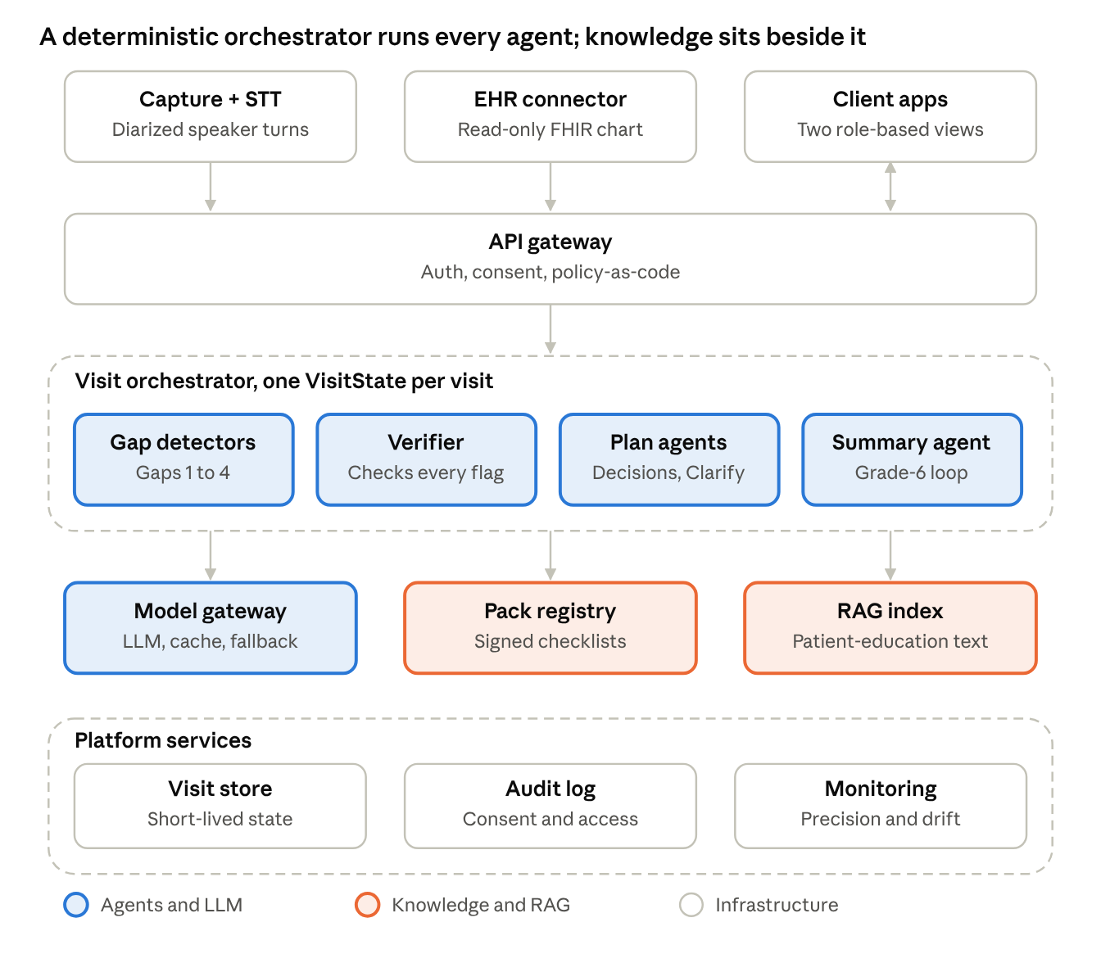
high-level design · layers, agents, knowledge, platform
How to read it, top to bottom
- Inputs. Spoken turns from speech-to-text, the patient's chart from the hospital record, and the two apps people use. Today only a replay of scripted transcripts exists.
- API gateway. Checks who is calling and that the patient consented, and applies policy rules written as code. This is a proposal for a real deployment.
- Visit orchestrator. Plain Python that holds the state of one visit and decides which agent runs next.
- Gap detectors. Four narrow agents that look for the four kinds of gap.
- Verifier. Rechecks every flag before anyone sees it.
- Plan agents. Capture what was decided and ask at most 3 clarifying questions.
- Summary agent. Writes the patient's plan at a 6th-grade reading level.
- Model gateway. The single door to the LLM, with a cache, retries and fallback from Groq to Gemini to Ollama.
- Pack registry. Holds the signed checklist for each condition. Teal means knowledge, and the checklist is fixed text, not retrieved.
- RAG index. Trusted patient-education text, used only to write the summary.
- Platform services. Short-lived visit state, an audit trail of consent and access, and monitoring of precision and drift. These are proposals.

2. Per-turn flow
Each spoken turn is scrubbed, checked by one agent chosen by who spoke, verified, and stored; only chart contradictions and unrepaired misunderstandings can surface during the visit.
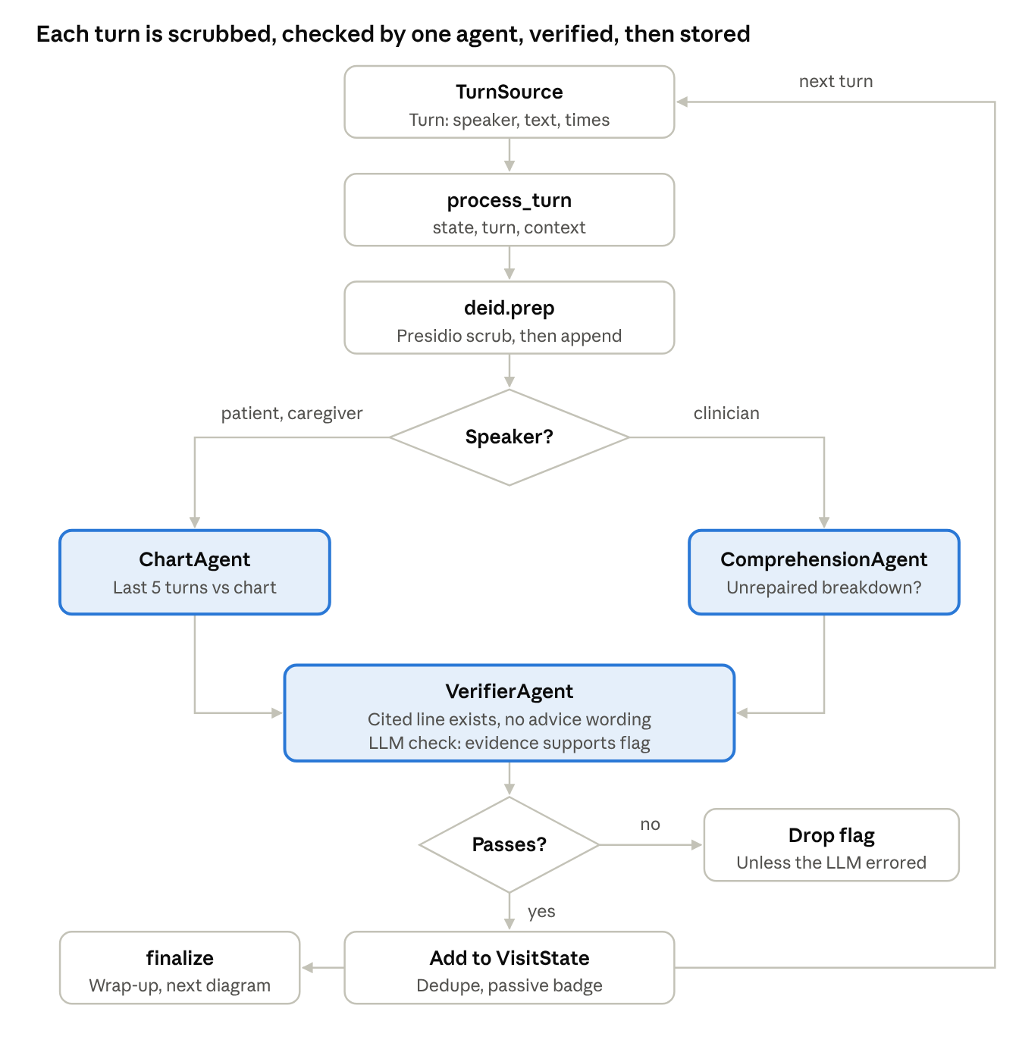
per-turn flow · one pass through the engine
Walk through one turn
- A turn arrives with its speaker, text and times. Today it comes from a replay of a scripted transcript; later it could be typed or spoken.
- process_turn runs with the visit's state and its context: the chart, the checklist and the LLM.
- deid.prep scrubs names, phone numbers and similar details with Presidio, then the turn is added to the visit state.
- If the patient or caregiver spoke, ChartAgent compares the last 5 turns with the chart. Example: the patient says no heart history while the chart lists a prior stent.
- If the clinician spoke, ComprehensionAgent re-reads the recent turns for a misunderstanding that was never repaired, such as a repeat request with no repeat. It can only judge after the clinician replies, so that flag appears on the next clinician turn.
- VerifierAgent runs two checks: the cited line exists, the quote matches and no diagnosis or treatment wording appears, then an LLM yes-or-no on whether the evidence supports the flag.
- A flag that fails is dropped. If the LLM itself errored, a flag that passed the first check is kept but marked unverified, and the eval does not count it.
- A flag that passes is deduplicated by type and evidence, added to the visit state and shown as a quiet badge.
- The loop continues with the next turn until the wrap-up arrives, which hands over to finalize.

3. Wrap-up flow
At wrap-up three detectors read the whole scrubbed visit once, the verifier checks every result, and the clinician sees a single end-of-visit list.
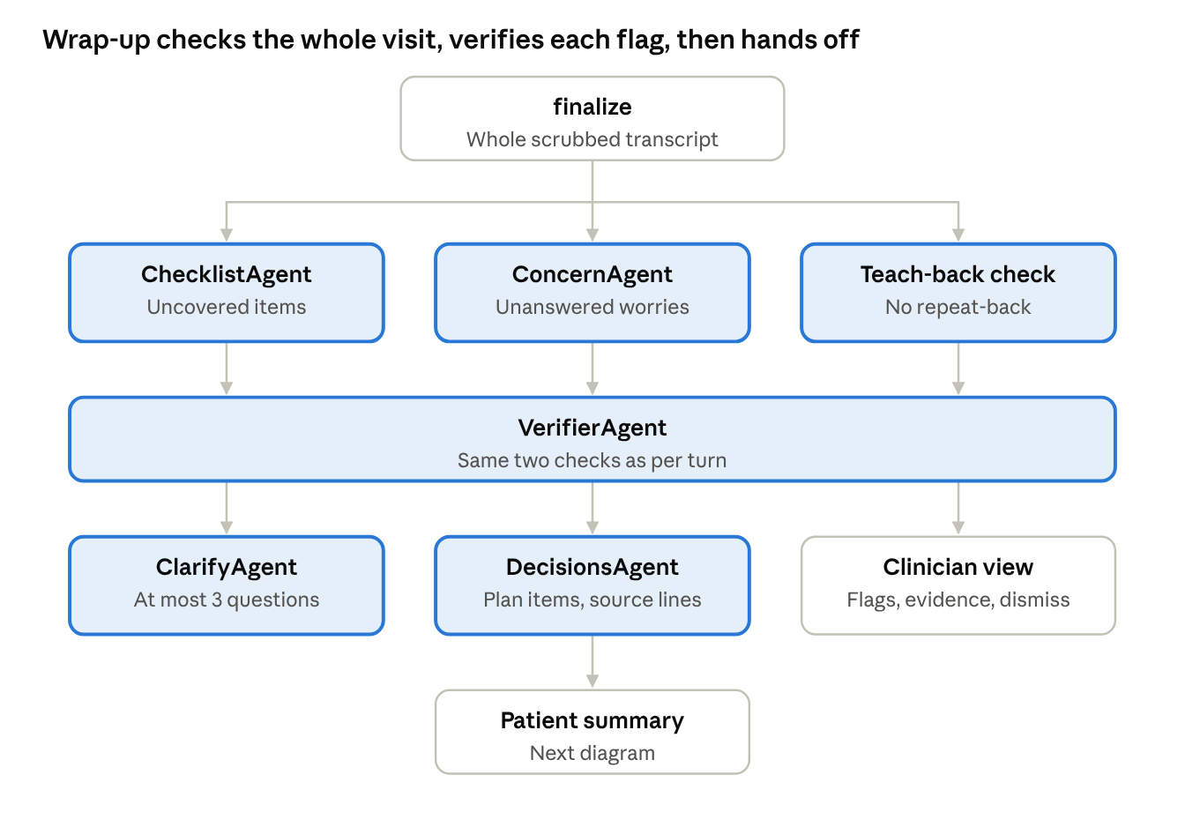
wrap-up flow · detectors, verifier, outputs
Why omissions wait until the end. A checklist question or a worry can still be handled later in the visit, so flagging it early would raise false alarms. Missing-question and unanswered-concern flags are therefore never raised before wrap-up.
- finalize runs after the last turn and hands the whole scrubbed transcript to three checks.
- ChecklistAgent returns, for each of the 10 checklist items, whether it was covered, with the turn and an exact quote. A coverage claim whose quote cannot be found counts as not covered. Uncovered items become missed-question flags.
- ConcernAgent finds worries the patient or caregiver voiced. A worry counts as answered only if a later clinician turn answers it.
- The teach-back check looks for plan, medication or warning-sign instructions where the patient never repeated the plan back, and points at the clinician's instruction.
- VerifierAgent applies the same two checks as during the visit, so only evidence-backed flags survive.
- The clinician view lists the surviving flags, each with its evidence line and a one-tap dismiss, and dismissals are logged.
- ClarifyAgent asks at most 3 questions about unclear items, such as a plan with no follow-up timing. DecisionsAgent collects what was decided, with the transcript line it came from, and feeds the patient summary. Both are in the v2 plan and not yet in the repo.

4. Patient summary with RAG
The patient's plan is written from trusted education text that an agent retrieves, then checked for reading level and for support in its sources.
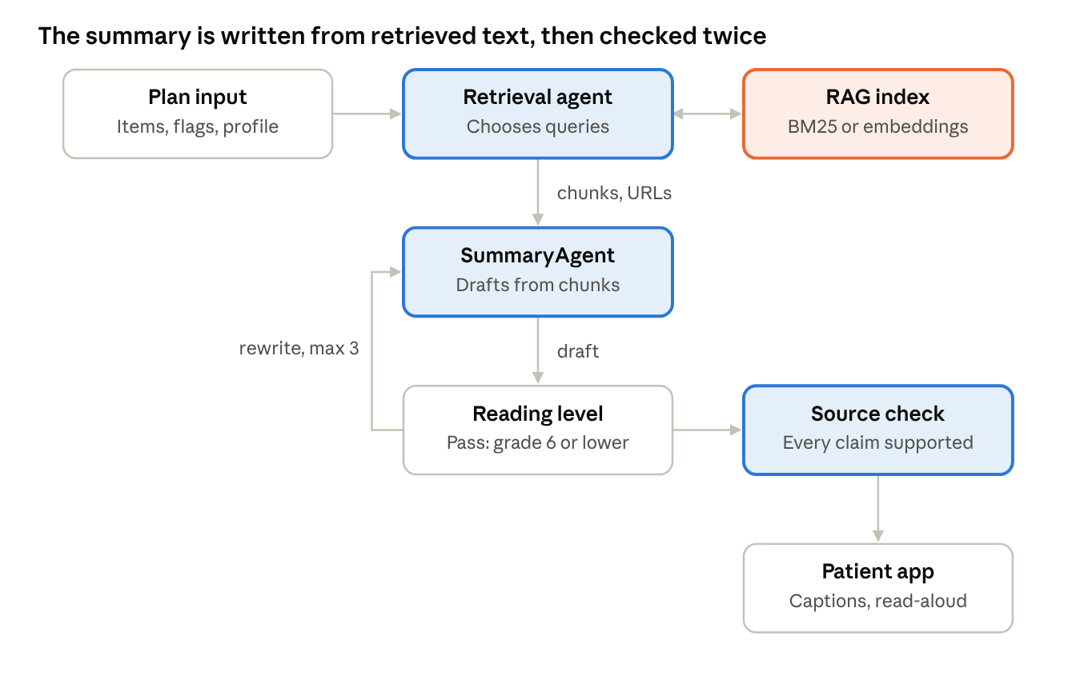
patient summary · retrieval, readability loop, source check
Why RAG is used here and nowhere else. An explanation of a warning sign should come from vetted patient-education pages, not from what the model happens to remember. Detection does not use RAG, because the checklist is a small fixed file and must behave the same every time.
- Plan input. The decided plan items, the verified flags and the patient profile (hearing level, literacy, caregiver present). The profile shapes the summary's length, style and teach-back questions.
- Retrieval agent. Picks search queries, looks them up in the RAG index, and searches again if the results are weak. The index holds patient-education pages from MedlinePlus, CDC and AHA (licenses to be checked), with a source URL stored on every chunk, and uses BM25 or precomputed embeddings so no heavy PyTorch install is needed.
- SummaryAgent. Drafts the plan, warning signs and questions for next time from the retrieved chunks, and attaches a citation to every explanation.
- Reading level. textstat scores the draft. If it is above grade 6, or too long, the agent rewrites it with the score as feedback, up to 3 drafts, then ships the best one and logs its grade.
- Source check. The verifier confirms each claim is supported by a retrieved source and flags the ones that are not.
- Patient app. Shows the summary with captions and read-aloud for patients with hearing loss, plus its reading grade.
Status: the summary agent and readability loop are built but have only run against a fake LLM. The retrieval agent and the RAG index are planned for Phase 5.

5. Pack authoring with RAG (proposed)
This is where a medical-knowledge RAG fits best: before any visit, helping a clinician build the checklist, never deciding gaps during one. It is a proposal, not part of the Oct 21 scope.
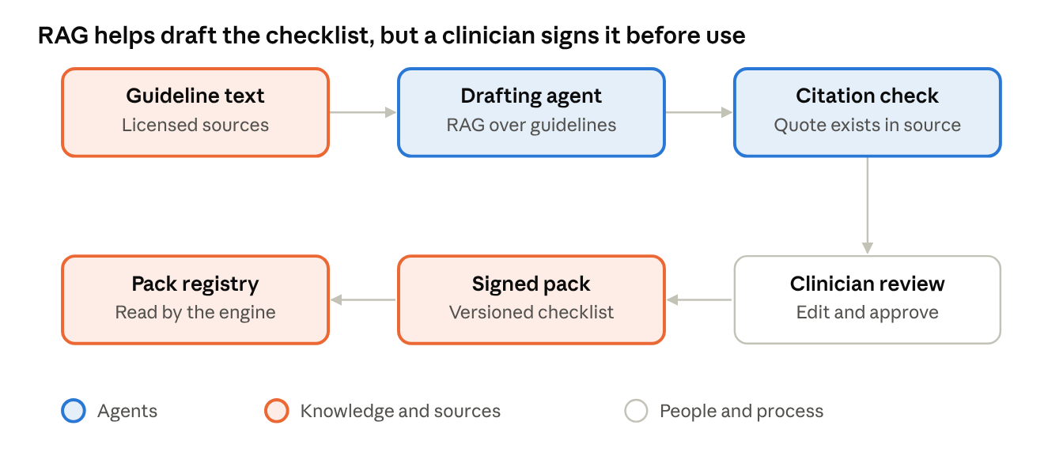
pack authoring (proposed) · guideline RAG to signed checklist
- Guideline text. The licensed guideline or the hospital's own pathway, for example the 2021 AHA/ACC chest pain guideline the current checklist was matched to.
- Drafting agent. Retrieves relevant passages from an index of that text and proposes checklist items, each with the passage it came from.
- Citation check. A verifier confirms every quoted passage really appears in the source, so no item rests on an invented citation.
- Clinician review. A clinician edits and approves the items. Today the checklist is matched to the guideline but has not had this review.
- Signed pack. The approved checklist becomes a versioned pack, with the chart schema and corpus for that condition.
- Pack registry. At runtime the engine reads the signed pack as fixed text. Nothing is retrieved or reinterpreted during a visit.
This keeps detection reproducible and auditable. A flag fires the same way on Tuesday and Wednesday, and every checklist item points back to guideline text a clinician approved. A new condition then means a new pack, not a change to the engine.

Data contracts
Every part passes typed objects, so a bad model answer is rejected before it reaches the screen. Field names come from the repo's SPEC.md and src/schemas.py.
Part | Takes in | Gives out
TurnSource | A replayed transcript now; typed or microphone input later | Turn: speaker (clinician, patient or caregiver), text, optional start and end times
process_turn | VisitState, one Turn, the context (chart, checklist, LLM) | Updated VisitState
ChartAgent | The last 5 scrubbed turns and the chart | Candidate chart-contradiction flag
ComprehensionAgent | The recent turns after a clinician reply | Candidate unrepaired-breakdown flag
ChecklistAgent | The whole scrubbed transcript and the checklist | Coverage per item; candidate missed-question flags
ConcernAgent | The whole scrubbed transcript | Candidate unanswered-concern flags
VerifierAgent | A candidate flag, transcript, chart | The flag with verified=True, or nothing
SummaryAgent | Transcript, verified flags, plan items | Patient summary text plus its final reading grade
Flag | Evidence from the verifier | Type, evidence pointers with verbatim quotes, rationale, verified, dismissed
An evidence pointer names its source (transcript, chart or checklist), a reference (turn number, chart entry or checklist item) and the exact quote. A missed-question flag points at the checklist item, since the finding is that no transcript line exists.

Built versus planned
The engine through Phase 3 is implemented in the repo, but no detector accuracy has been measured. This table comes from the repo's SPEC.md and PROGRESS.md; the source folders could not be read, so it reflects what those docs claim.
Part | Status
Orchestrator, process_turn, finalize, de-identification | Built
Chart, Comprehension, Checklist, Concern and Verifier agents | Built; tested against a scripted fake LLM; quality unmeasured
LLM client with cache and fallback | Built; Groq verified live, Gemini and Ollama only against mocked HTTP
Checklist pack (10 items) | Built; matched to the guideline, not clinician-reviewed
Summary agent with readability loop | Built; never run live
Eval harness | Not started (Phase 4)
Streamlit UI | Not started (Phase 5)
Retrieval corpus and retrieval agent | Not started (Phase 5)
Clarify and Decisions agents | Planned in the v2 prompt; not in the repo docs
Gateway, audit log, monitoring, EHR connector, speech to text, signed pack registry | Proposal for a real deployment, not in scope for Oct 21
Pack authoring with RAG | Proposal

Glossary
Term | In plain words
Agent | One focused LLM call with a fixed job and a fixed answer shape
Orchestrator | The ordinary program that decides which agent runs next; not an AI
LLM | The language model that does the reading and judging inside an agent
RAG | Retrieval-augmented generation: look up trusted text first, then write the answer from it
Verifier | The check that a flag's quoted evidence really exists and supports the flag
De-identification | Scrubbing names, phones and similar details before text reaches a hosted model
Gap | Something the visit missed: an unasked question, an unanswered worry, a chart contradiction, or an unrepaired misunderstanding
Wrap-up | The end-of-visit moment when omission flags are allowed to surface
Passive badge | A quiet indicator during the visit; no pop-up and no sound
Teach-back | The clinician asking the patient to repeat the plan in their own words
Pack | A swappable bundle of checklist, chart schema and corpus for one condition
Verified flag | A flag that passed both verifier checks; the only kind the eval counts

Sources
The built-versus-planned facts and agent behavior come from the repo docs below. The Clarify, Decisions, retrieval, platform and pack-authoring parts come from the v2 master prompt or are proposals and are labeled as such. The guideline cited for the checklist is the 2021 AHA/ACC Guideline for the Evaluation and Diagnosis of Chest Pain.
- Dr.Listner repository
- SPEC.md
- PROGRESS.md

